Mozambique Hash House Harriers invite you to join the Greatest Africa Hash Pre-Ramble ever!
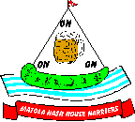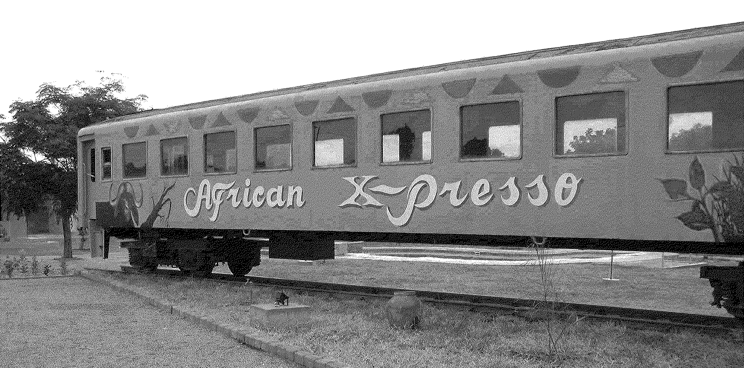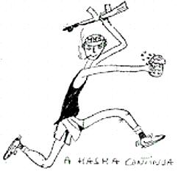

2005 Africa X-Press, Maputo to Cape Town Pre-Ramble 1st – 8th April 2005

Ever dreamed of a romantic train journey through Africa? Forget the Blue Train, take the 2005 Africa X-press as it journeys from Mozambique through Swaziland, Zululand, the Free State and the Garden Route to arrive at Cape Town for Africa Hash 2005! The kind of luxury trip that the tourists pay big bucks for, but we're going to Hash it (1st Class) for only R5300!! After some hashing and a grand send-off Hash Bash in Maputo we’ll be stopping at locations in Swaziland and South Africa to hash with the local H3 or to set our own trails. In an easy timetable with most of the traveling at night there’ll be time for seeing a bit of bush and wildlife, a bit of African culture and a bit of classic Cape and Garden route scenery, and Hashing through it!.
The Train starts in Johannesburg, so we can pick up Jacaranda and Jo’burg Hashers and any Internationals who landed there. After a stop at Komatipoort, we’ll start the Pre-ramble with a hash and party in Mozambique with Maputo and Matola H3’s. The train then proceeds to Swaziland for some real Africa Hashing, hosted by Hhohho H3 in and around the wildlife parks of Eastern Swaziland. Then on its one long hash party down South Africa, Hash with the Hippo Hash and Zululand H3, see the Last Outpost of Empire with Durban H3, and on on through the scenery of the Free State, into the Garden Route through Port Elizabeth and George!!
We have already booked the train. It consists of six 1st class carriages, a double dining coach and a lounge/bar and will take 144 hashers maximum in compartments of 2 and 4. We have about 50 signed up already, and judging form the interest so far the remaining places will go fast. This is your warning, book early if you want to travel on the Africa X-Press!!.

NB; More details will be available as we get nearer the date. Once you have registered you will receive regular up-dates

Price
As in the past, our policy is to keep prices as low as possible consistent with comfortable quality hashing, and to pass all the value on to the hashers. There will be a hash cash account prepared after the event, and any surplus will be spent in extra beers etc. or handed back. My estimate is that it will not cost more than R5300 all in per head on the basis of 144 hashers starting from Maputo, and we will start taking bookings now on that basis. There will be a supplement for joining the train in JHB and reductions for those who miss the Maputo Hash night and join in Swaziland or later down the track in SA. These prices will I hope be maximums, and with some good bargaining or sponsorship we could reduce them (but it is possible they could increase). If costs reduce after you pay you’ll get money back, if they go up you won’t pay more.

NB Registrations payable in Rand. The dollar figures given in the early version of this info were for comparative purposes only and the rate has changed since the date it was issued. We need to receive the South African Rand amount stated above, net of all bank charges. Please specify to your bank that you will bear all charges. (Typically the charges to the receiving account are about 90 Rand per transfer, which is in addition to whatever your bank charges you.)

Registration
Fill in the attached form and send it to Bwana at robert.david.walker@mz.pwc.com Payment details are on the form.

Cancellations and Transfers of Registrations

A registration can be transferred to another unregistered hasher at any time at no cost. Both parties must e-mail Bwana to confirm the transfer. Cancellations must be notified by fax or e mail to Bwana. Notification does not avoid payment for the cancelled place. However, only unavoidable costs will be charged to cancellations. The cost of empty beds is R2200 each, and this amount is the minimum cancellation charge unless the train is full on departure, in which case a full refund will be given. This charge will apply to cancellations notified before 1st March 2005. After 1st of March no refund for cancellations is guaranteed. Refunds after this date will be at the discretion of the Committee and will be based on actual costs.

Sponsors:

We are looking for sponsors for all stages of the journey. Sponsors donations will be used to provide T Shirts and other goodies or to reduce costs. The publicity offered sponsors will be very prominent. Call Bwana about sponsorship.

Provisional Itinerary and Programme

(this programme will be developed and improved, although the start and end are fixed)

Day | Date - 2005 | Place | Activity
Thursday | 31st March | Johannesburg, | Train leaves JHB at 18.00 for Komatipoort , Mpumalanga.  Hashers starting in JHB could travel on the train.
Friday | 1st April | Maputo | Bus Komatipoort - Maputo (1 hour) for those arriving from JHB by train.  Register for the 2005 Africa X-press  (Train leaves Komatipoort for Swaziland Big Bend)  15.00 - Hash with Maputo & Matola H3's  Overnight Hotel in Maputo – Hash Party
Saturday | 2nd April | Big Bend (Swaziland) | 8.00am bus to Swaziland to train (1.5 hours)  Hash with Hhohho (Mbabane) H3, Hlane National park  Lunch at Hlane Game Lodge  Train leaves for Richards Bay -overnight
Sunday | 3rd April | Richards Bay  (Zululand) | Hash with the Hippo H3 and Zululand H3  Lunch at Traditional Zulu village  Train Leaves for Durban -overnight
Monday | 4th April | Durban (Natal) | Hash with Durban H3  Lunch in Valley of 1000 hills  Train leaves for Bloemfontain -overnight
Tuesday | 5th April | Bloomfontain | Sightseeing -possible trip into Lesotho with Maseru H3  Train leaves for Port Elizabeth -overnight
Wednesday | 6th April | Port Elizabeth  (Garden Route) | Hash and lunch in Port Elizabeth  Train leaves for George -overnight
Thursday | 7th April | George  (Garden Route) | Sightseeing in George  Train leaves for Cape Town -overnight
Friday | 8th April | Arr. Cape Town | Register for Africa Hash 2005

On In; Smuggly from Copenhagen H3 writes;

One piece of information that might be of use for hashers flying in from Europe intercontinental with South African Airways but possibly also other companies that are cooperating with SAA in the so called Star Alliance - Lufthansa, Austrian Airways, and more) the price for a flight to Jo'burg and Cape Town is the same - and the plane to Cape Town always stops over in Jo'burg. Meaning that you can fly into Jo'burg from Europe, get off the plane and continue by train to Cape Town and fly back to Europe from Cape Town. on the same ticket and without extra expense.

On On
Bwana
For the Mozambican 2005 Africa X-press Committee
Bwana is R.A. and Founder of Matola H3, Mozambique
Organiser of Harare Pre-Ramble to AH 1999 (Vic Falls), Richards Bay/Zululand Pre-Ramble to
AH 2001 (Durban) and Kili-Ma-Ramble Tanzanian/Kenyan pre-ramble to AH 2003 (Mombasa).

