AFRICA INTER HASH
POST -RAMBLE
Victoria Falls
Zimbabwe

April 15 - 18 2005

THE PUSSY WANTS MORE!!

Brave the majesty of the mighty Victoria Falls and the Zambezi River

Run with the beasts

Register Now!!

Where you'll be staying!!

The A’Zambezi River Lodge

The A'Zambezi River Lodge is nestled on the banks of the Zambezi River. This river frontage provides huge shady trees at the edge of the lush gardens. A'Zambezi is a comfortable middle range hotel and all 86 rooms and suites have air conditioning for your comfort. Located 5 kms from the Falls, this hotel offers peaceful tranquillity, just a few minutes from the bustling town.

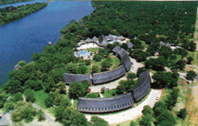
It is the only hotel situated right on the banks of the great Zambezi River just a short way upstream from the mighty Victoria Falls. The A'Zambezi River Lodge offers a truly Zimbabwe cultural experience from its amazing welcome to the delicious traditional dishes on offer. Here is the atmosphere for real Africa that ably complements the stunning beauty of the Falls themselves. Here you can immerse yourself in the ethnic splendour of the region.

An added attraction for an unforgettable experience!

Livingstone Trail
Three Day Two Night Canoeing Safari

12 - 14 April, 2005
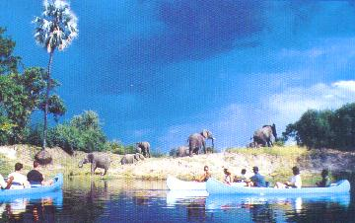
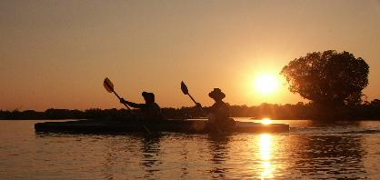
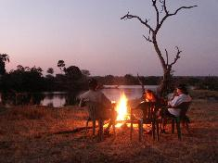

A multi-day canoeing safari on the Zambezi River above the Victoria Falls is an experience worth including in any itinerary. This is an absolutely incredible part of the Zambezi with so much variety.
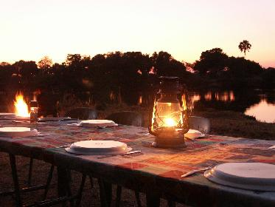
Spend two nights in backed up tented camps on the banks of the Zambezi, along with a canoeing safari done during the day.
There certainly is no need to concern yourself with whether it would be too strenuous, since the river is moving at such a rate that you can almost drift down without having to paddle much at all. There is no better way to experience wildlife and bird life than from a canoe drifting silently past, and the incredible scenery provides a majestic backdrop to the days expedition. The overnight camps are fully backed up and you will be pampered to the extreme by our staff as you relax and enjoy the beauty of a Zambezi Sunset.
On the Livingstone Trail, follow the route that David Livingstone used to access the Falls. Explore the magnificent Zambezi River, stretching back above the falls, with its intricate islands, channels and rapids. Take the time to discover the secrets of the African bush in the Zambezi National Park.
Livingstone, camped along the banks of the Zambezi, very close to where you will overnight during your two nights on the river. He was paddled in a Makoro, by Lozi tribesmen, a tribe still resident in the area. The game was excellent at the time so his sightings must have been brilliant, and fortunately, the Zambezi National Park on the upper reaches of the river, for the first two days of this trip is still very much untouched even though it is so close to the Falls.
On this trip you will be accompanied by a professional guide, who will be instrumental in sharing with you insightful information about your encounters and experiences, through their extensive knowledge. In their company, the unbounded intricacies and diversity of the bush, bird and wildlife become truly captivating. You will have the opportunity to experience the pristine African bush.

Please note there is a National Parks entry fee of US$ 15.00 per person payable on entry
COST PER PERSON IS US$ 450. 00

Bungi jump or white water raft!!
Harare Hash in conjunction with Cansaf Adventures can work in an unforgettable holiday for you around the Post Ramble Weekend

